# Eclipse for the Web

<https://www.youtube.com/watch?v=PS-IGzBMboQ>

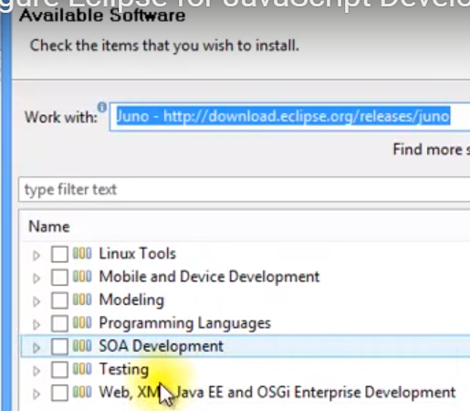

selection

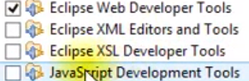

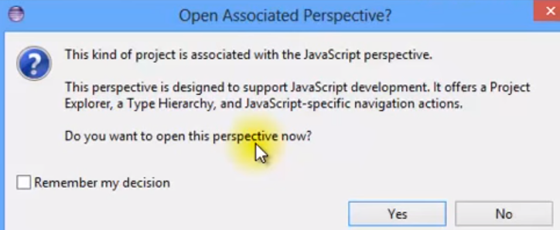new project



test wrapper → html onclick

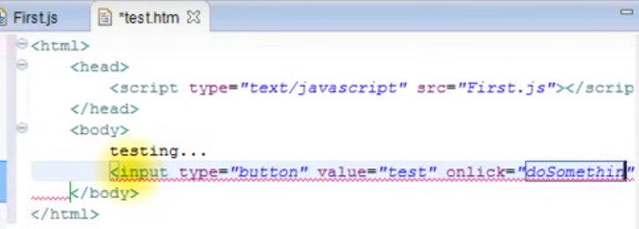run it

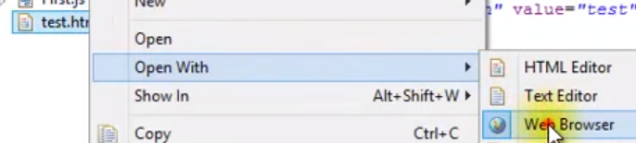

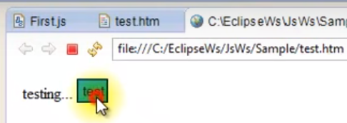

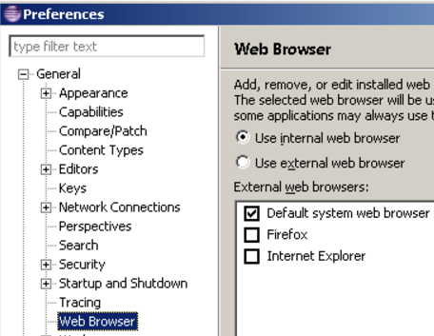

# Chrome

discontinued → inside Eclipse

<https://code.google.com/archive/p/chromedevtools/>

This debugger enables you to debug JavaScript running inside Google Chrome tabs from the Eclipse IDE.

inside Chrome

<https://developers.google.com/web/tools/chrome-devtools/>

# Webclipse

<https://www.genuitec.com/products/webclipse>

commercial → debug browser side !!

<https://www.genuitec.com/products/myeclipse>

# Angular Eclipse Plugin

<https://www.youtube.com/watch?v=RSwG4Zo81cQ>



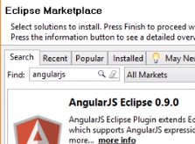

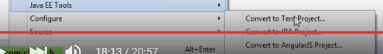

---------

# Login Page

<https://www.youtube.com/watch?v=xGkYWhRTiAA>

# Node.js in eclipse

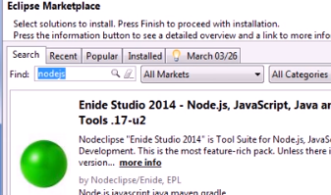

# Big Data

<https://www.youtube.com/watch?v=ASiU89Gl0F0>

Reshuffle Aggregates

→ cannot all be held in one relational structure !! → no relational → no SQL

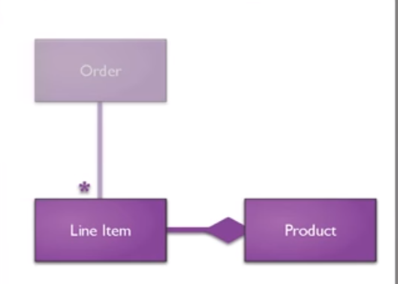

Aggregate Oriented → map-reduce of all data, instead of join

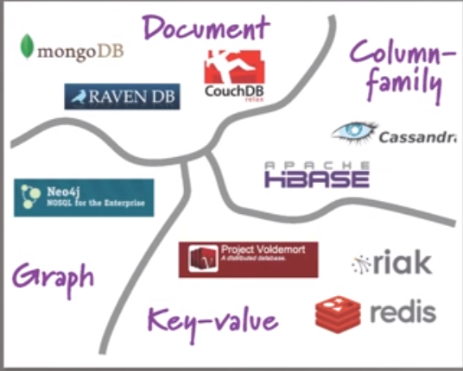

Graph on other side of SQL !!! → common: schema-less

Many-Joins → 100s

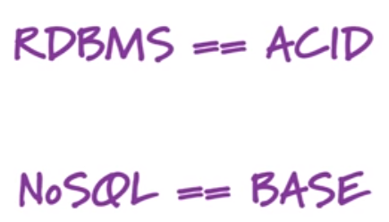

Graph → ACID

BUT: Replication never ACID

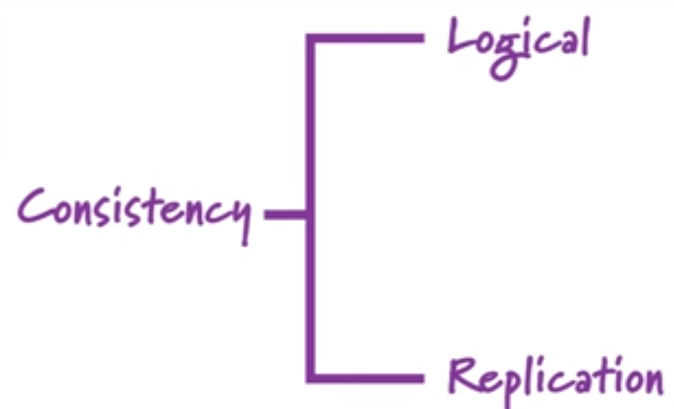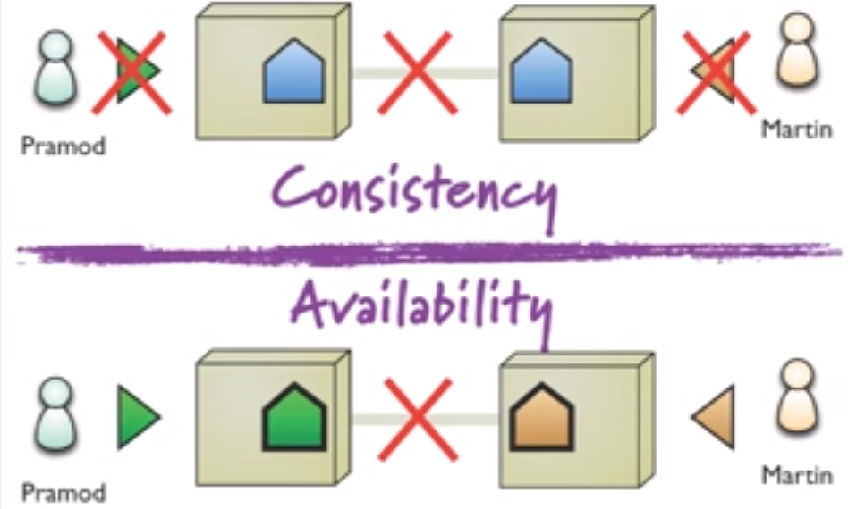Business Decision → Airplanes always over-booked !!

Availability can also mean „response time“ (world-wide system) → Cache Invalidation



Two reasons:

Easier Dev → Natural Aggregates

Large Data → Only some instances

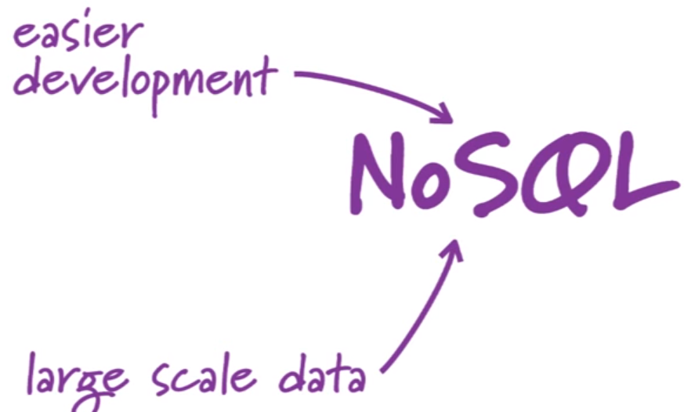

# Cassandra

<https://www.youtube.com/watch?v=B_HTdrTgGNs>

linear performance scaling by adding nodes

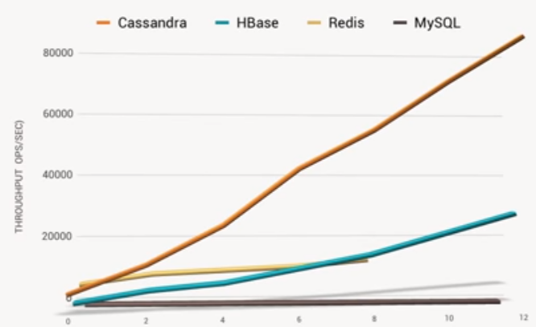

Write:

1) Persistent Log

2) in-memory Mem-Table

3) Other Nodes

Compaction

1) All Files read-only

2) Merge several files into one new one (asynch + sequential)